VIRTUAL JOURNEY: THE ARCTIC CIRCLE ON STAMPS.

DAVID R WRIGHT

A journey round the Arctic Circle is almost as long as the journey from Pole to Equator, yet there are only 8 countries to visit. I have visited six of the eight countries – but have only reached the Arctic Circle in three of them. For six of the eight countries, the Arctic regions are remote areas, and so the Arctic is rarely seen on their stamps. I guessed that it would be a challenge to find enough stamps, but I need not have worried: there are some wonderfully ‘atmospheric’ stamps from all eight countries. I am focussing on the landscapes and life in these areas.
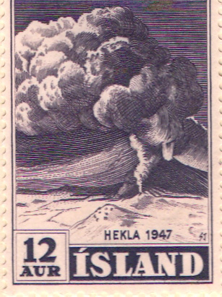
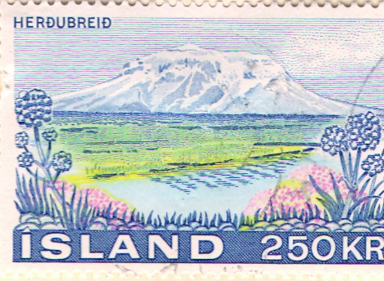
We’ll start our journey in Iceland – a country which, surprisingly, only just reaches the Arctic Circle in the far north. Iceland has produced outstandingly evocative stamps for many years. The island was colonised and settled by the Vikings a millennium ago; it is the only country in the world to have written records that go back to the first inhabitants. The combination of ice and fire [volcanoes] provide ideal themes for stamps.

The 12 aur Hekla eruption stamp over a snowy landscape is hard to beat – and the whole set is magnificent. More recently, a 250 kr stamp shows us a high snowy mountain formed long ago by a volcano, which contrasts with the green lowland, complete with summer flowers. This stamp sums up my main memories of Iceland – a visit is warmly recommended, and it is not far away…..

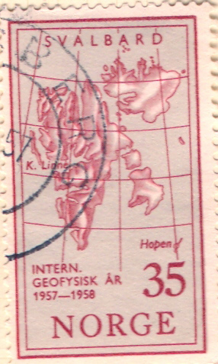
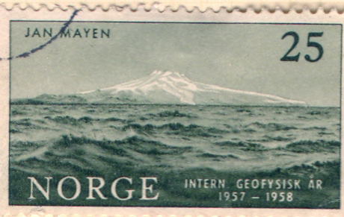
We’ll travel eastwards. Northeast of Iceland is remote Jan Mayen Island, at 71 degrees north – a Norwegian island. In 1957 Norway issued a set of stamps for the International Geophysical Year. The 25 ore stamp is the chilliest stamp I know – a rough grey sea, with the snow-covered peaks on the island below a threatening grey sky. In the same set, the 35 ore stamp has an excellent map of Svalbard – except for omitting the latitude and longitude numbers – Svalbard reaches an impressive 80 degrees north.

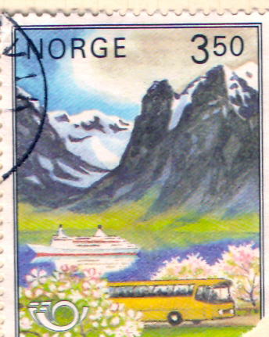
We then travel to the mainland of Norway; the 3.50 kr of 1983 is a big contrast to Jan Mayen Island. This is a friendly, sunny landscape: a classic view of a deep fiord, whose depth is proved by the huge liner. Above the fiord are superb glaciated mountains with snowfields. In the foreground, fruit trees are in flower, and a postbus is waiting to take us to town. The view is well south of the Arctic Circle, but the snow on the mountains shows the arctic climate at high altitudes.
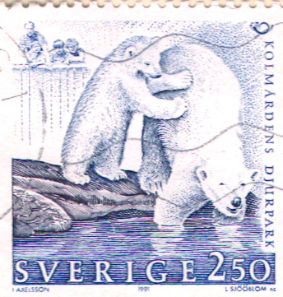
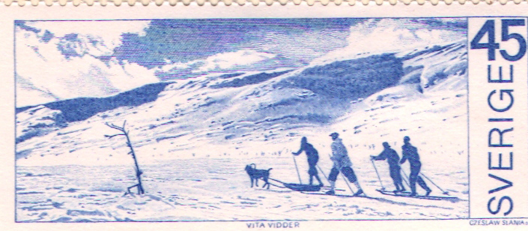
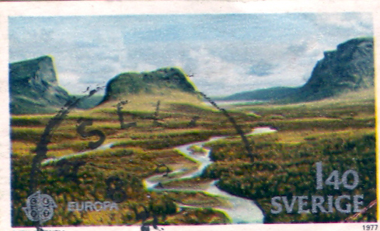
Sweden does not have an Arctic Ocean coastline, so the polar bears on the 2.50 stamp seem surprising at first sight. But look harder: at the top left of the stamp, a family is watching the bears. It’s a zoo: the Djurpark! But the soft and gentle colours make it a memorable stamp. In fact, Sweden has a large area north of the Arctic Circle. The harshness of the northern snowfields are well expressed on the 45 ore stamp. Summer in the north is brief but beautiful: on the 1.40 stamp of 1977, a river flows across the marshy tundra landscape, with steep glaciated mountains in the distance.

For much of the year, this landscape will be snow covered.

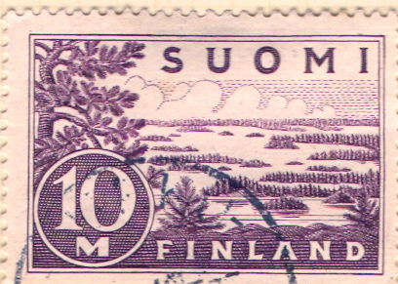
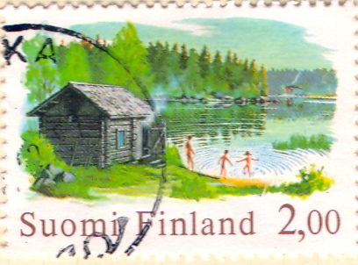
Finland – land of 1000 lakes – captured the essence of their ice-scoured, lake-dotted landscape on a 10 ore stamp over 50 years ago. On a 2.00 stamp we see the Finnish idyll of a wooden summer house beside a lake, with a family enjoying the brief summer – and even braving the chilly water. Further north in Finland, the trees give way to tundra, where the frozen subsoil prevents trees growing. The 2.40 stamp shows the last trees before the tundra. The stamp conveys well the sense of vastness and emptiness that characterises northern Finland.

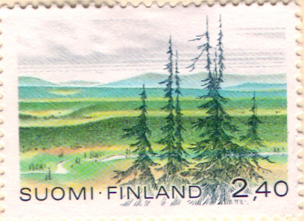

Over half the world’s land north of the Arctic Circle is in one country: Russia. The USSR issued excellent Arctic stamps, but the post-USSR government seems less interested in its Arctic landscapes. In 1989, only two years before the USSR collapsed, tundra was superbly captured on a 10K stamp with a linked map.
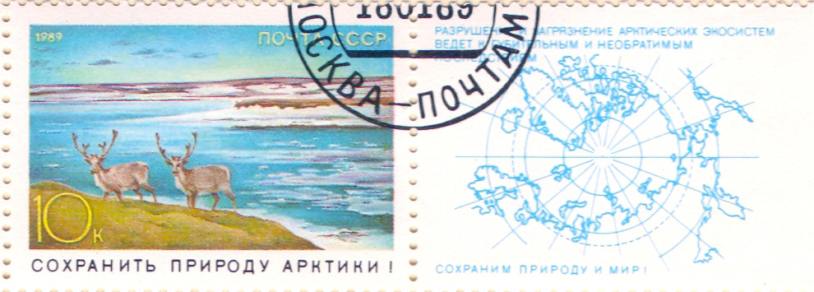
On this stamp, the reindeer are alert in the treeless marshy landscape; melting ice in the Arctic Ocean reveals some small islands. The slogan translates as ‘Preserve Arctic Nature’.

Two years earlier, in a remarkable act of international co-operation, WWF persuaded the USSR to issue a set of four stamps showing polar bears in the Russian Arctic.
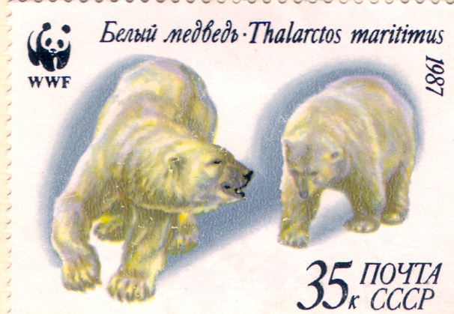

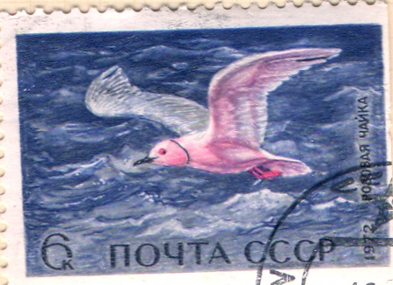
The distinctive pink gull only found in the Arctic is shown on a 6k stamp – further evidence of a concern for conservation.

The Kamchatka peninsula in the far east of Russia is beside the Bering Sea, well south of the Arctic Circle, but the volcanic mountains have an arctic climate, even though there is a summer landscape in the foreground.

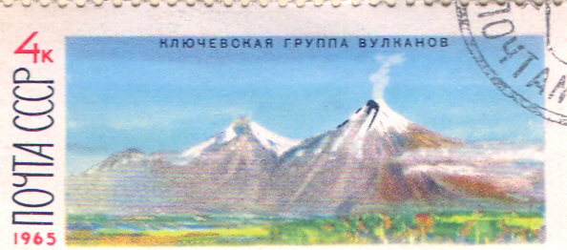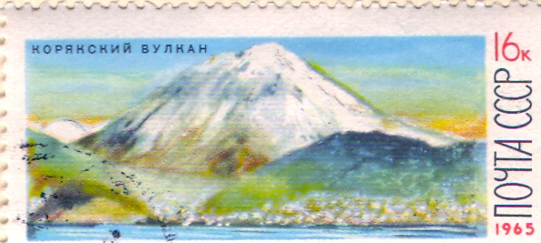

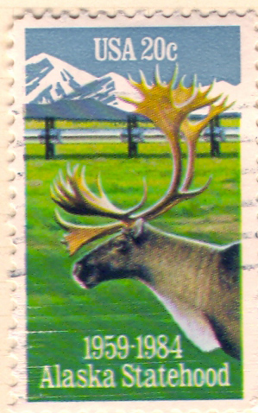
Alaska is very close to eastern Russia, and was owned by Russia until 1903. Now it is the 50th state of the USA. In 1984, a stamp celebrating 25 years of statehood captured well the contrast between the green foreground and the white snowy background.

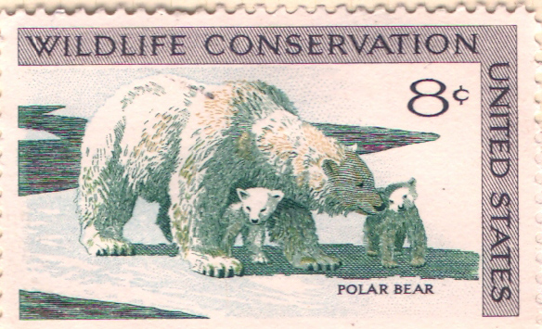
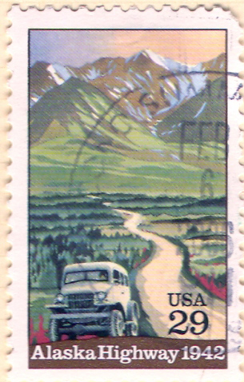

In 1992, a 29c stamp confusingly dated 1942, to celebrate the 50th anniversary of the Alaska Highway. The vintage truck on the road is a nice period-piece, but the main appeal of the stamp is the high, remote mountains which are so characteristic of Alaska. A contrasting stamp is the 8c polar bears [plural, despite the caption] – a delightful study of a mother and two cubs.

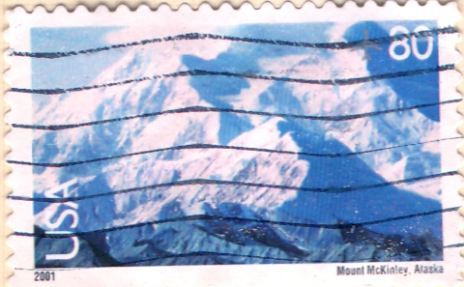
Mt.McKinley is the highest peak in Alaska, and also in the whole of the USA. The 80c stamp of 2001 is an outstanding stamp, because it captures the snow, sunshine and deep shade so well. Often, photos used on stamps are disappointing, but this one is excellent. It has arrived on innumerable air letters from the USA, and is always welcome.

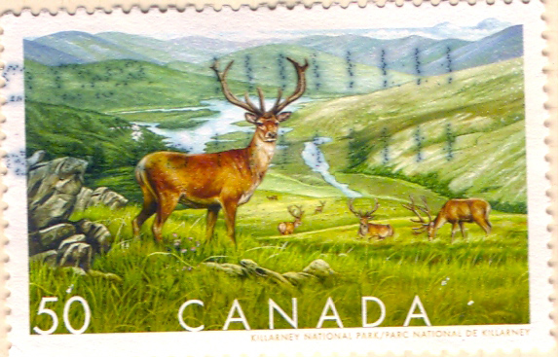

Recently, conservation is the dominant theme, and the view of Killarney National Park on the 50c stamp shows a beautiful summer landscape, complete with magnificent caribou.

Of course Canada has polar bears as well! Choose between a magnificently lonely one on the $2 stamp, or a splendid contre-jour pair on the 25c, with long deep shadows from summer evening sunshine.
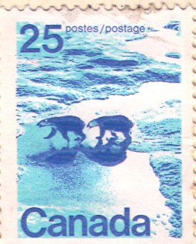
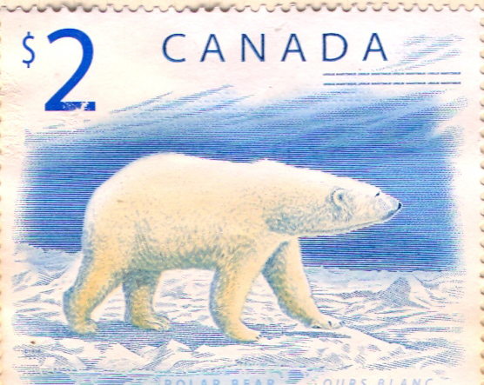

Our final country is the most amazing one of all the eight. Recently its stamps have become much more varied and exciting. They have portrayed every type of whale – strangely, the 1996 ‘killer whale’ on the 0.25 stamp seems to be the most handsome.

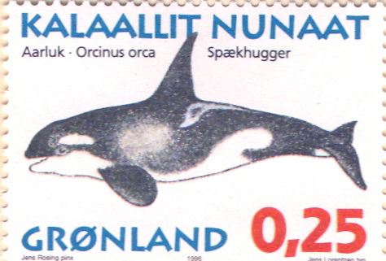

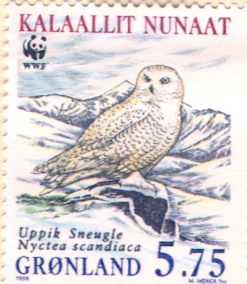
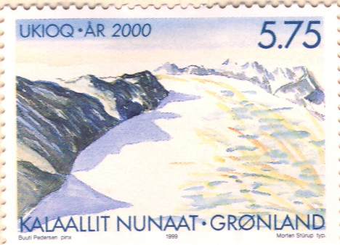
I have also chosen a 1999 snowy owl in an icy landscape, from a WWF-sponsored set, and a fine 1999/2000 evocation of a valley glacier flowing between jagged mountain ridges. Greenland’s stamps can be warmly recommended!

The journey round the Arctic Circle has led to the discovery of varied and attractive stamps. The themes of snow and ice, mountains and tundra, are similar on the whole journey – but each country interprets the themes in distinctive ways to express the qualities and challenges of these remote landscapes. It has been a rewarding journey.

David R Wright’s website is www.dandjwright.co.uk

