Feedback mechanisms
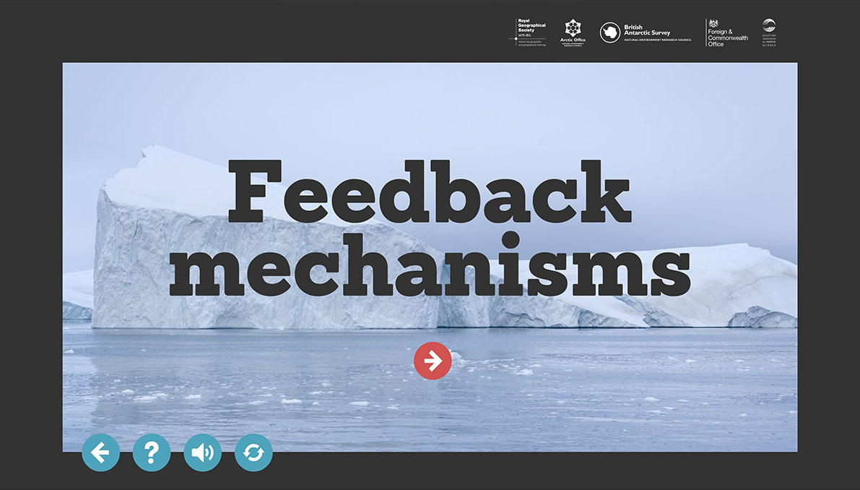

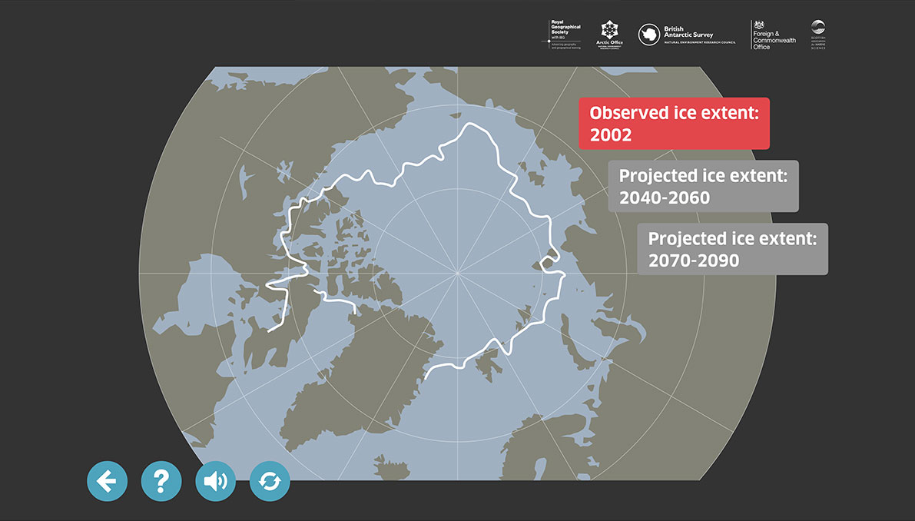
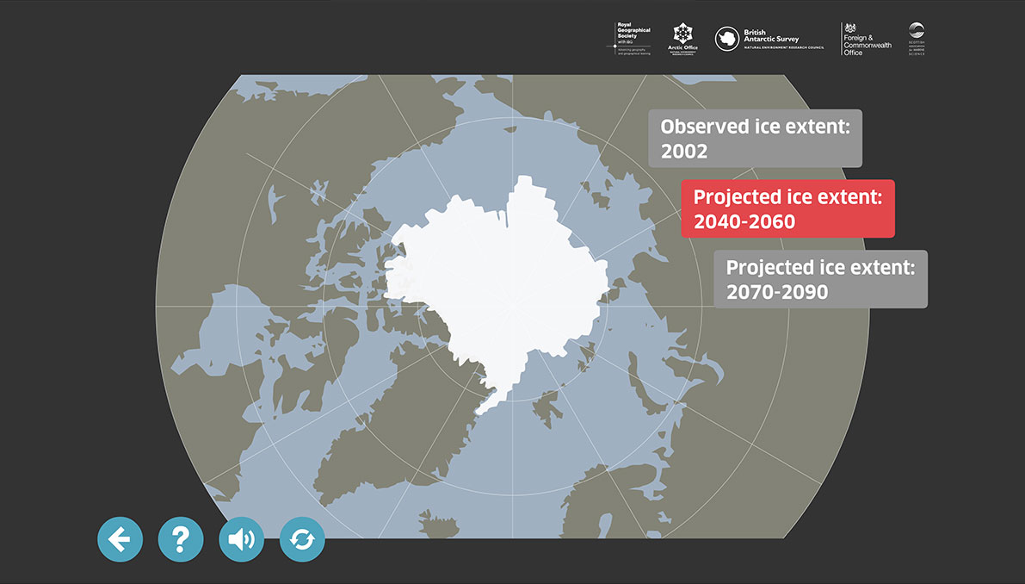

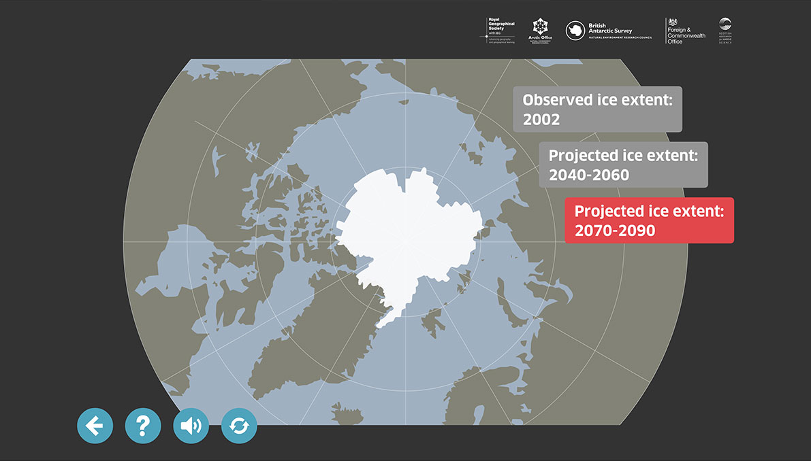

Melting snow and ice:
Positive feedback loop
As ice and snow melts, the surface becomes darker. As the darker ground absorbs more heat, melting takes place more quickly. It becomes more difficult for ice to form and for snow to lie on the ground. The amount of radiation reflected is called the albedo of a surface; light colours reflect heat, darker colours absorb heat.

Water vapour increase:
Positive feedback loop
A rise in temperature means that more water vapour is held in the atmosphere - this can act like a blanket, causing further temperature increase and a greenhouse effect.

Cloud cover
Positive feedback loop
More water vapour leads to more clouds, and so heat is trapped.

Cloud cover
Negative feedback loop
Clouds have a light coloured surface, so more heat from the sun is reflected back into space.

Iceberg formation
Negative feedback loop
As the temperature rises ice sheets break up, creating larger numbersof icebergs, which increase reflection.

Iceberg formation
Positive feedback loop
If all the ice sheets and icebergs melt, then the earth's surface will become darker and absorb more heat.

Carbon dioxide biofeedback
Negative feedback loop
Increased carbon dioxide increases growth of plants which fix carbon and reduce the amount of carbon dioxide.

Temperature
Negative feedback loop
As temperature rises so does surface radiation from the atmosphere into space.

