A Fine Balance
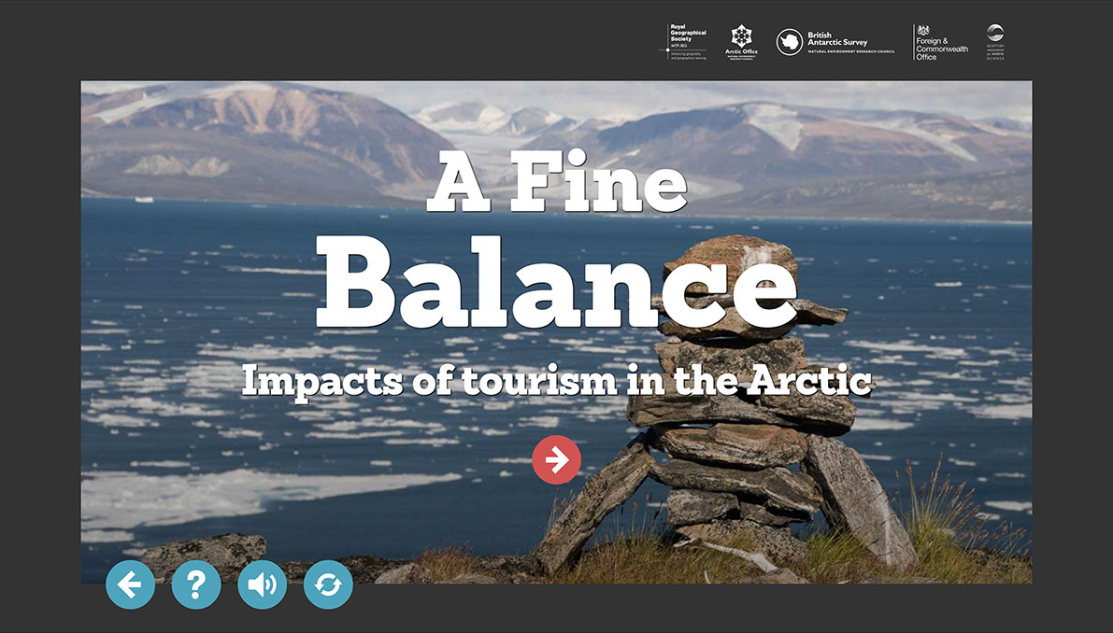

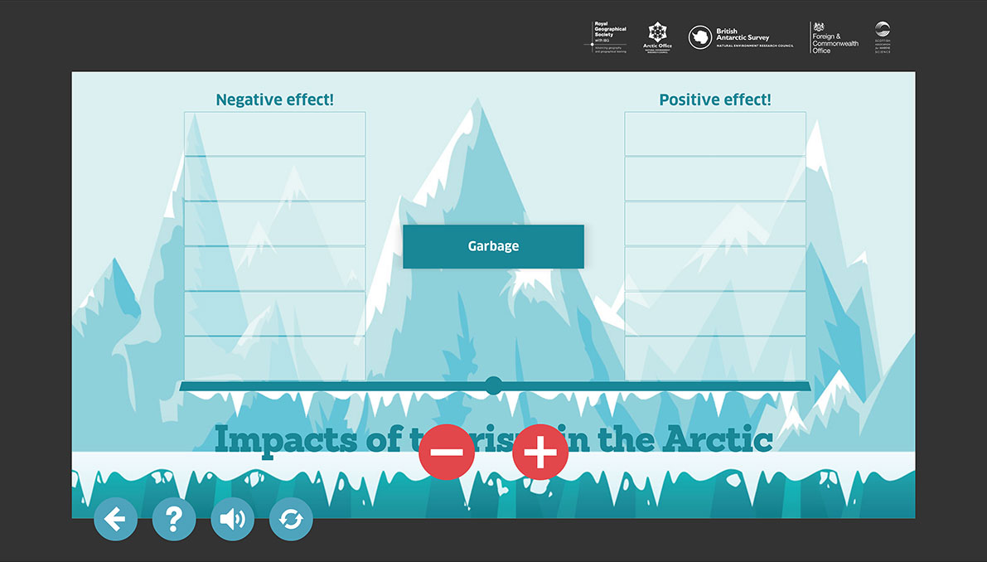

Balance the following examples of positive and negative aspects of tourism.

Emissions, Responsible tourism activities; Pollution; Promotes respect for Arctic cultures; Impacts on indigenous people’s way of life; Supports conservation; Disturbs wildlife and vegetation; Source of additional income for local people; Human waste; Source of sustainable income for local people; Garbage; Increases awareness of environmental issues.

