Walking on Snow
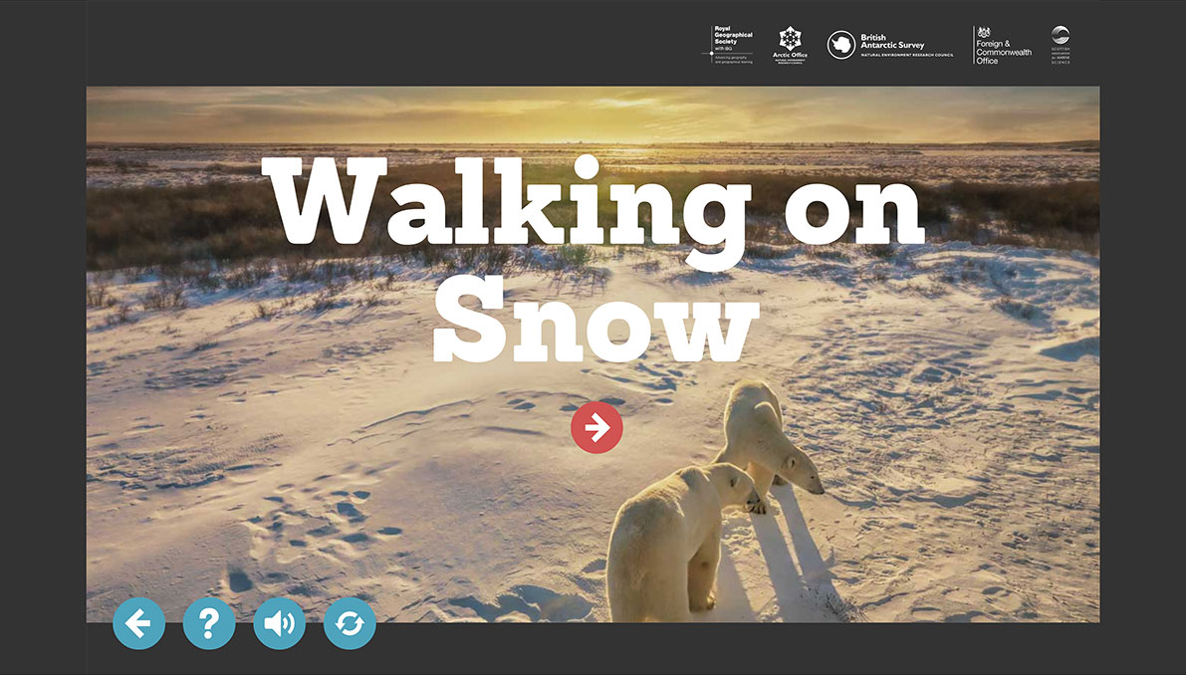

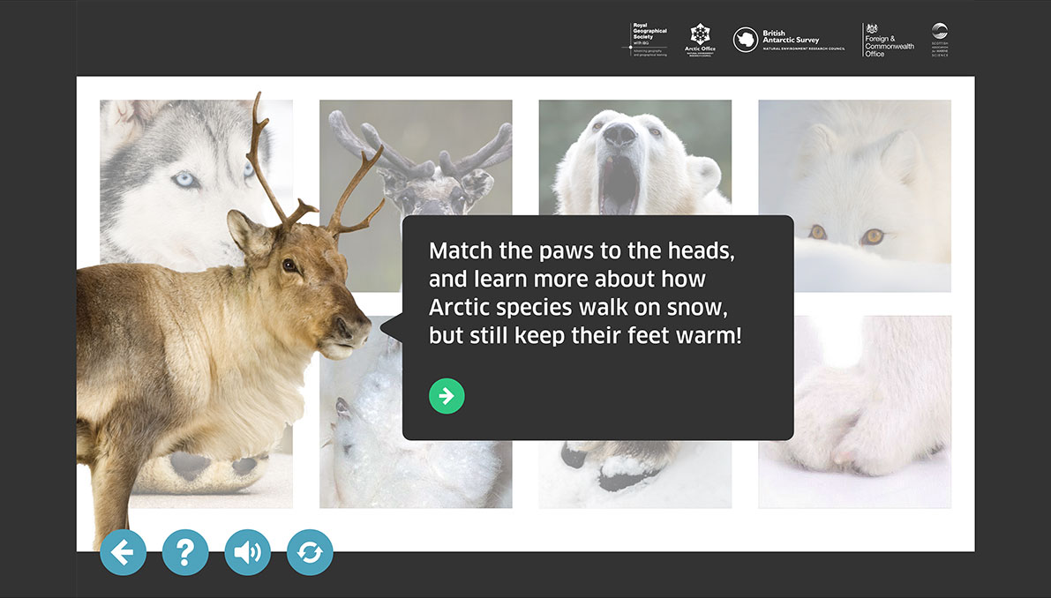
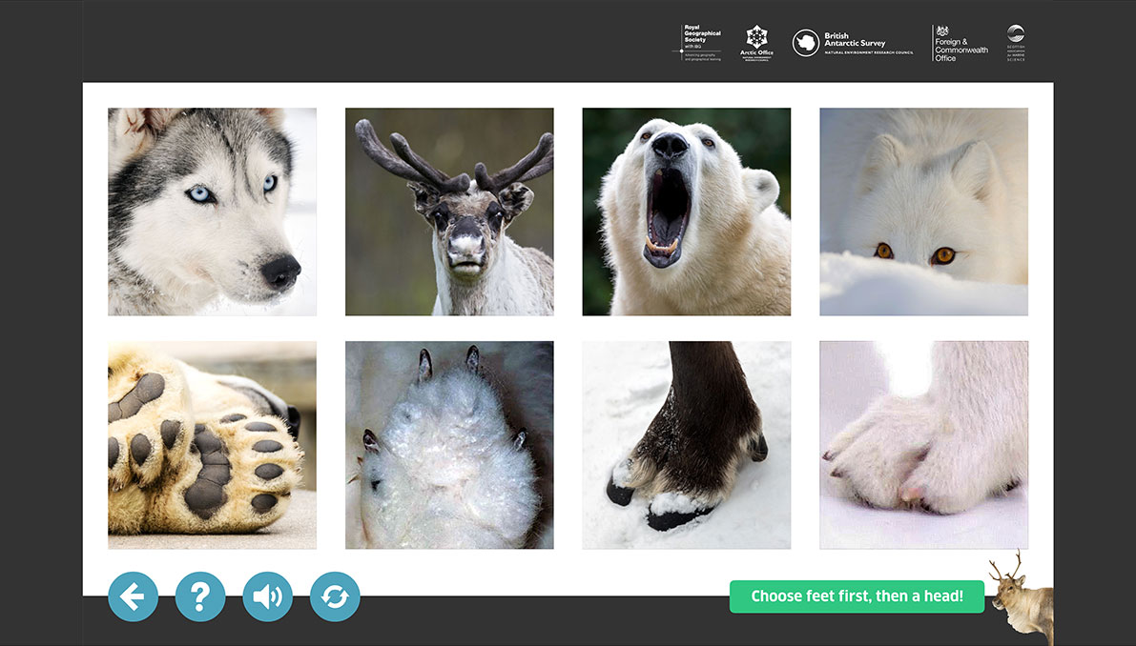

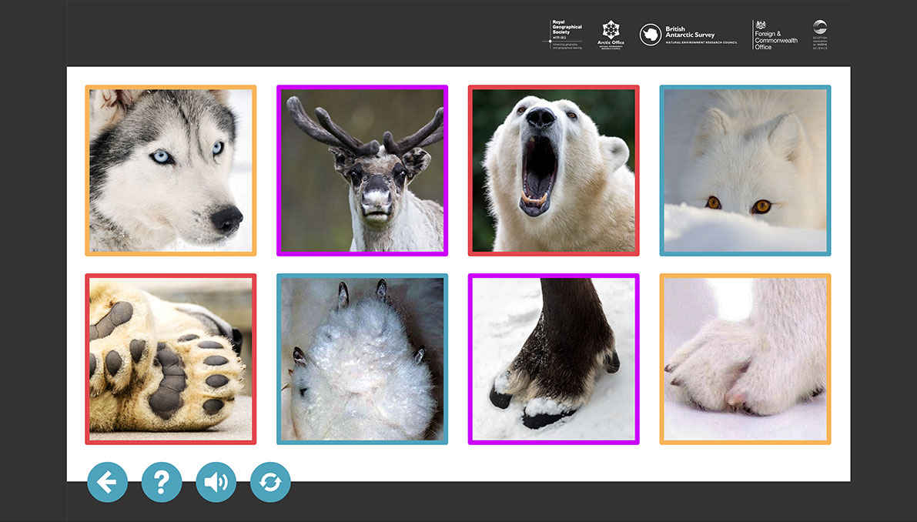

Polar bear: Polar bears have large feet, to help them walk on snow. They also have oily fur and a layer of blubber 5-15 cm thick, lying beneath the skin, to protect them from the cold. They are well insulated and can easily overheat when running. To cool down they lie on their backs with the soles of their feet in the air!

Reindeer: Reindeer have wide hooves fringed with fur that act like snowshoes, spreading their weight, so they can walk on deep snow without sinking.

Husky: Greenland dogs have small feet, which splay out and spread the weight so they don't sink into the snow.

Arctic fox: Arctic foxes have fur 'that covers their paws during winter. It can be for insulating against walking on cold ice and snow. But it can also help them to walk without sound when they hunt seal pups in snow caves in the snow in April and May ...The Arctic fox has short rounded ears and short muzzle compared to their relatives the red fox. All Arctic animals protect themselves physically against cold by growing a coat of fur. The Arctic fox experience a seasonal change in fur depth by 200%. The fur has the ability to trap and hold a layer of air next to the skin that increases the insulation. The Arctic fox has one of the best insulated fur in the world' (Eva Fuglei- Norwegian research scientist/biologist and Arctic fox specialist)

